This file displays some of my knowledge of:

* SQL queries (Joins, Concat, Aggregates, Clauses)
* Reports
* Stored Procedures (Sprocs)
* Views
* Database Diagram (if you’re curious)

**Example 1: Query and Report**

Demonstrates the use of the CONCAT operator, the SUM aggregate, and the join, where, and group by clauses.

Shows the current season’s status of each players: goals, minutes played, and penalties (grouped by teams). Players listed by full name using concat operator, teams listed by team name, and query sorted by team, player and goals.

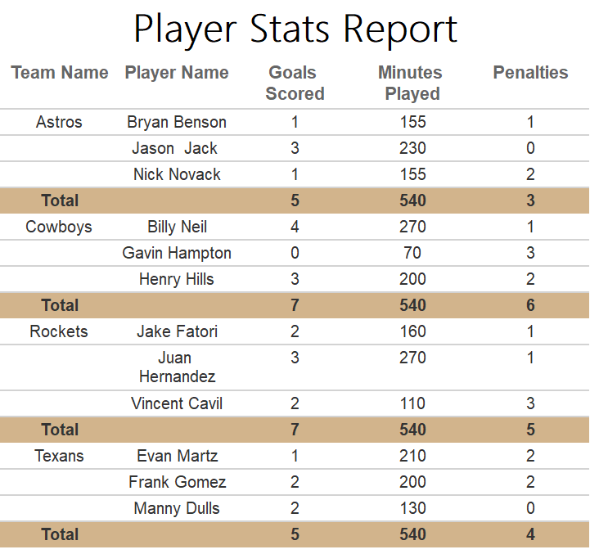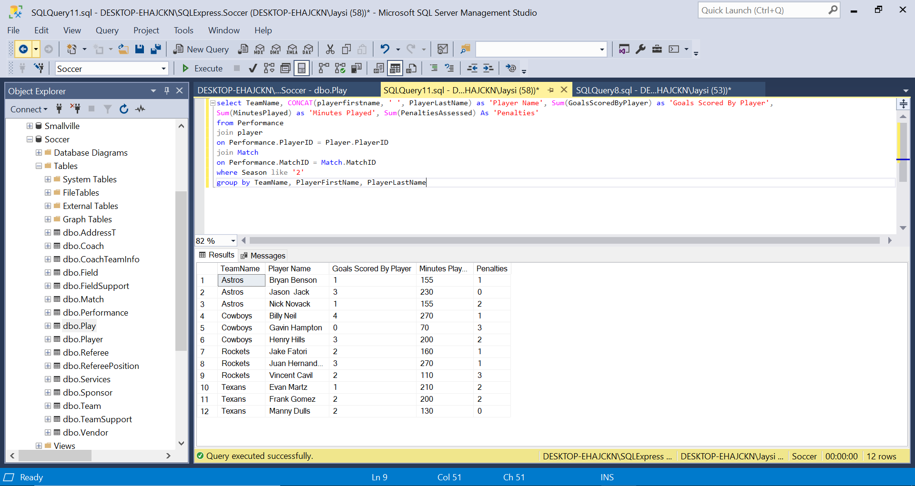

**Example 2: SPROC**

Demonstrates the use of stored procedures with parameters

Showing each team’s roster with a parameter for team name.

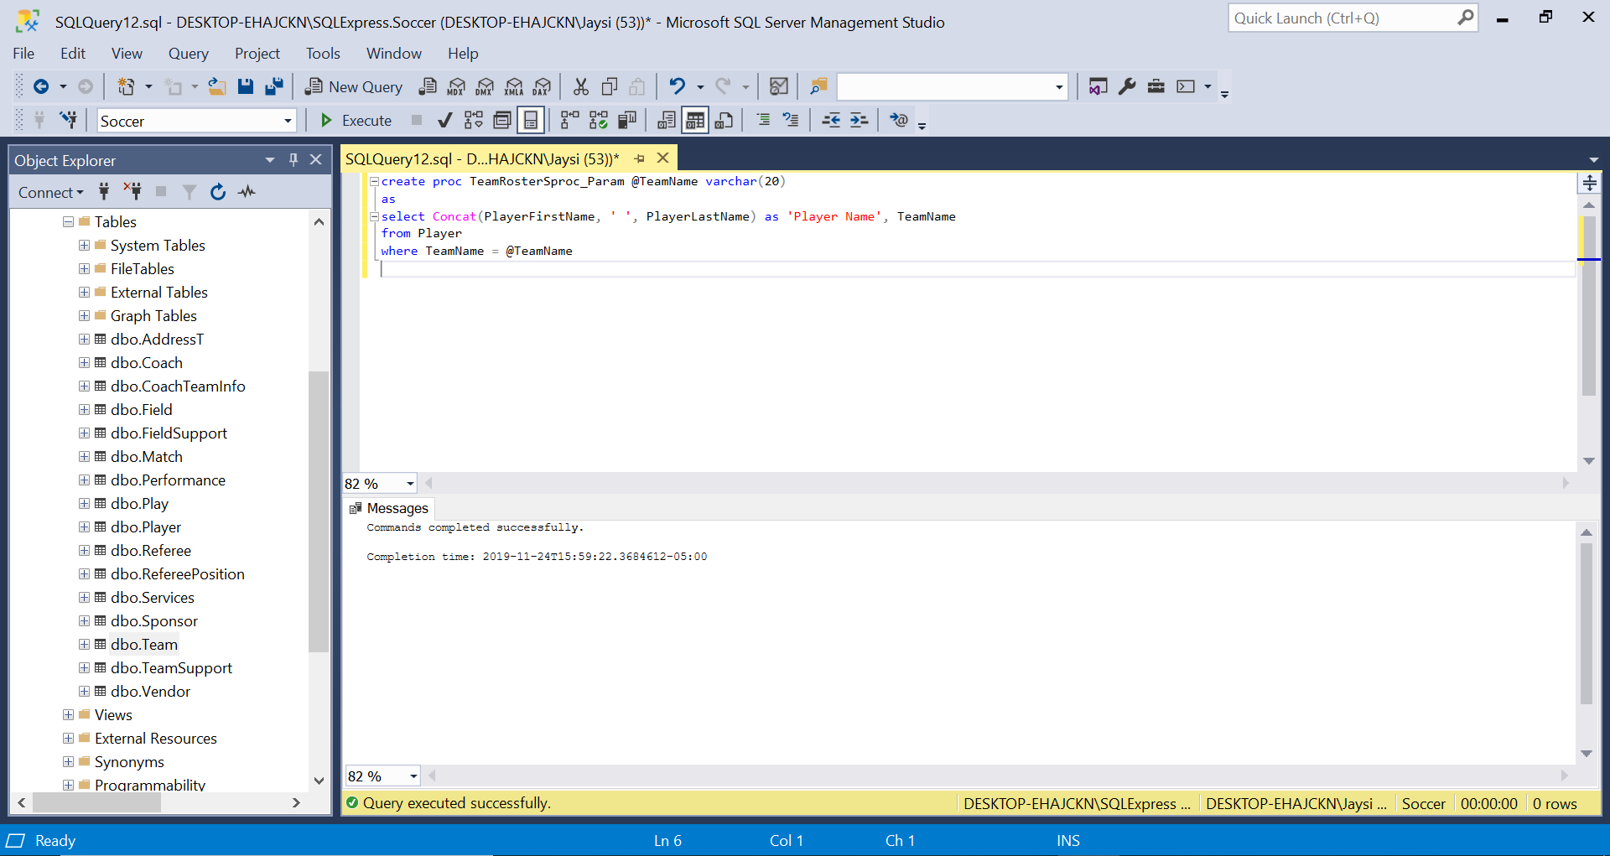  
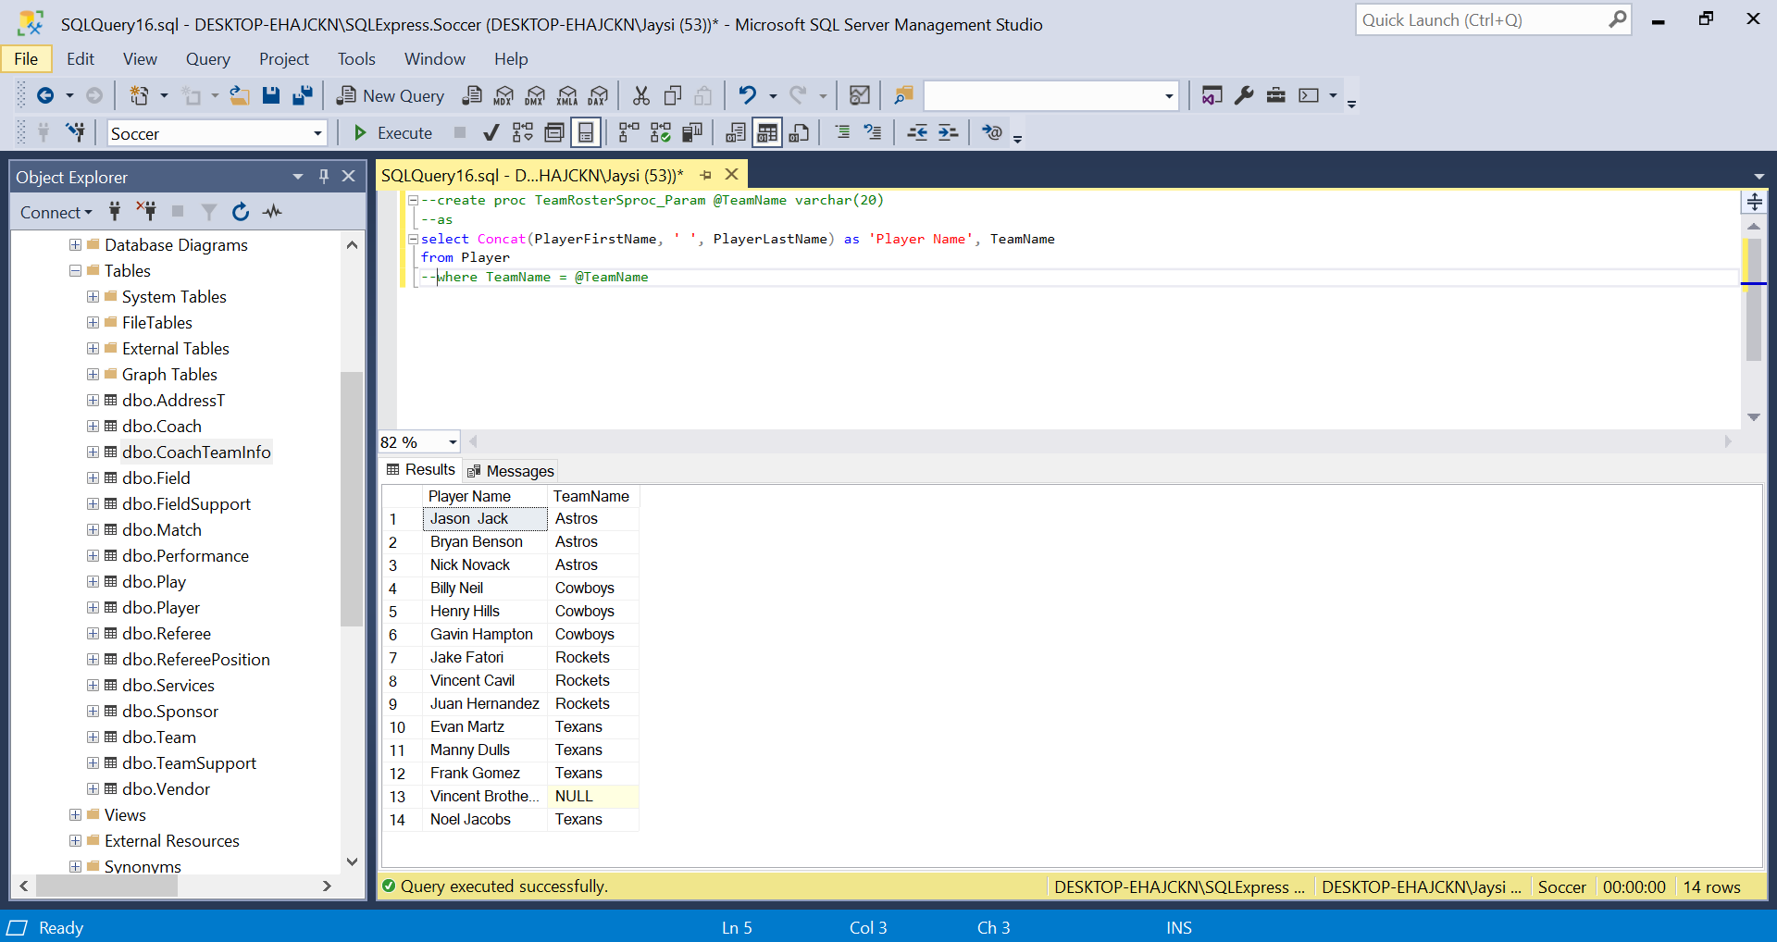

**Example 3: View**

Demonstrates the use of Views and data validation for no repeating values

Shows each team by season, team name, head coach, and contact number. (Rocket’s head coach changes between seasons to show there are no repeating values, just the same head coaches for different seasons)

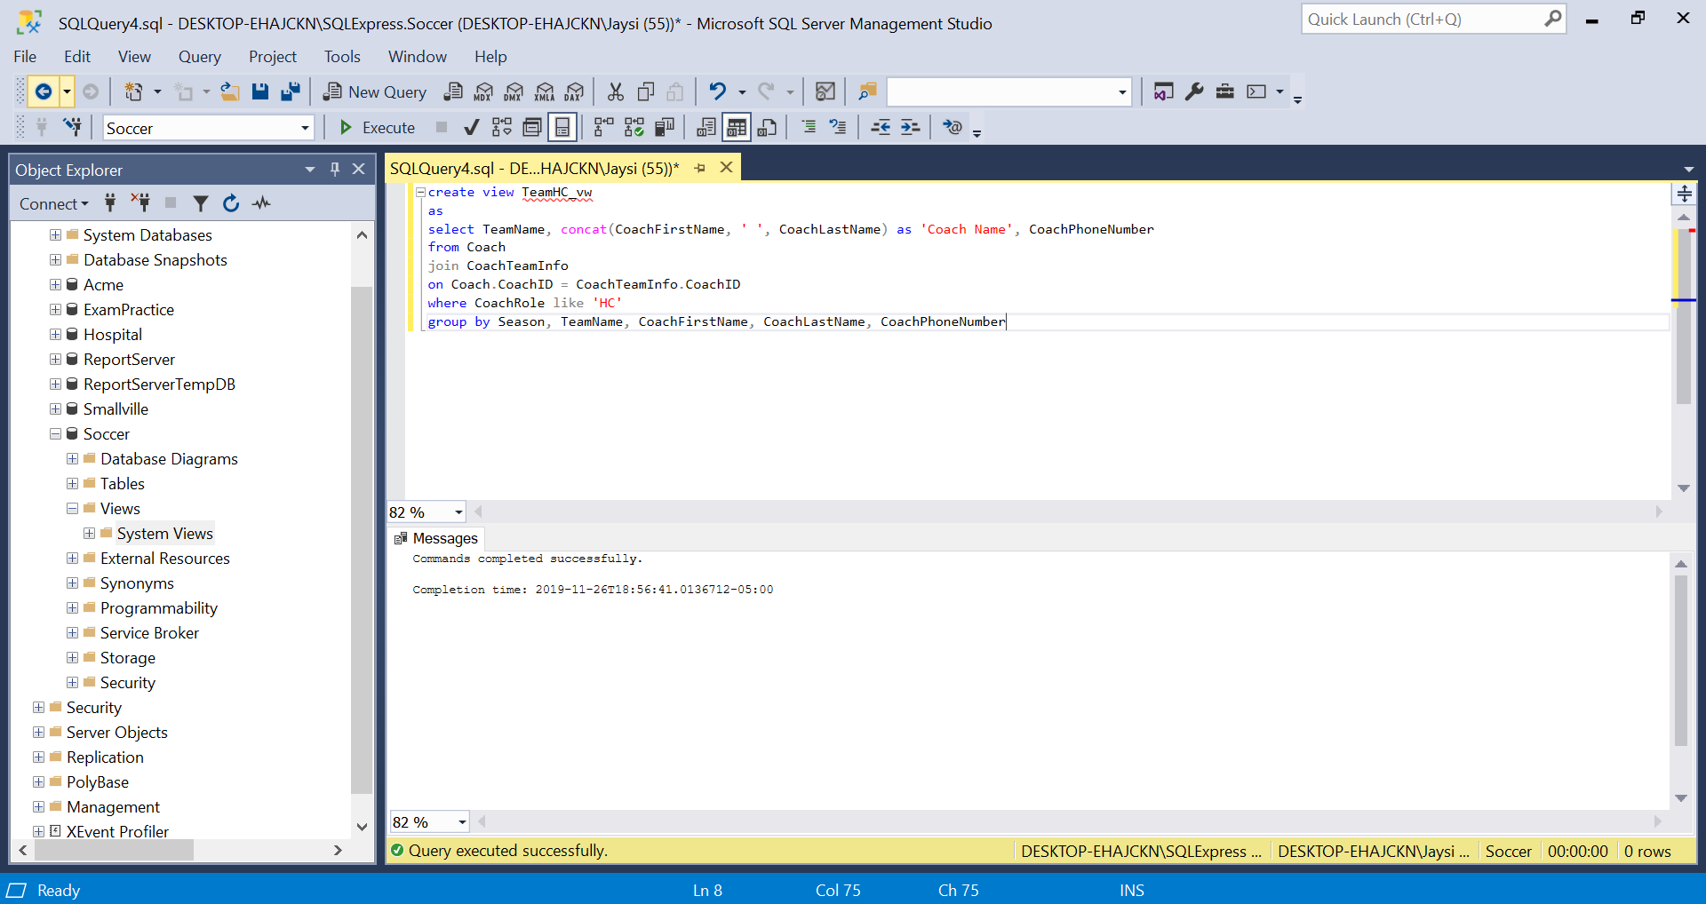

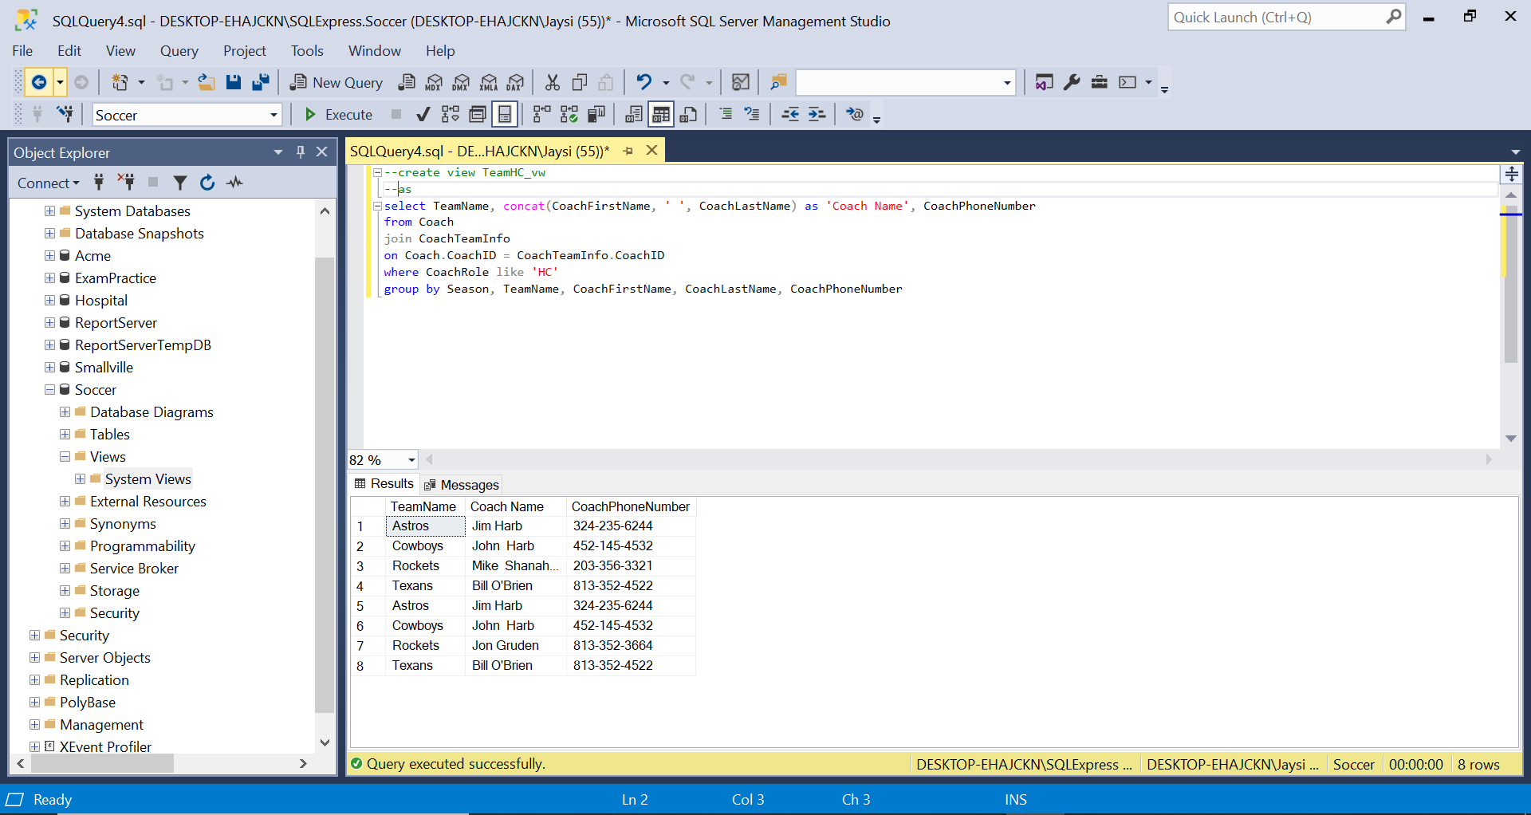

**Database Diagram**

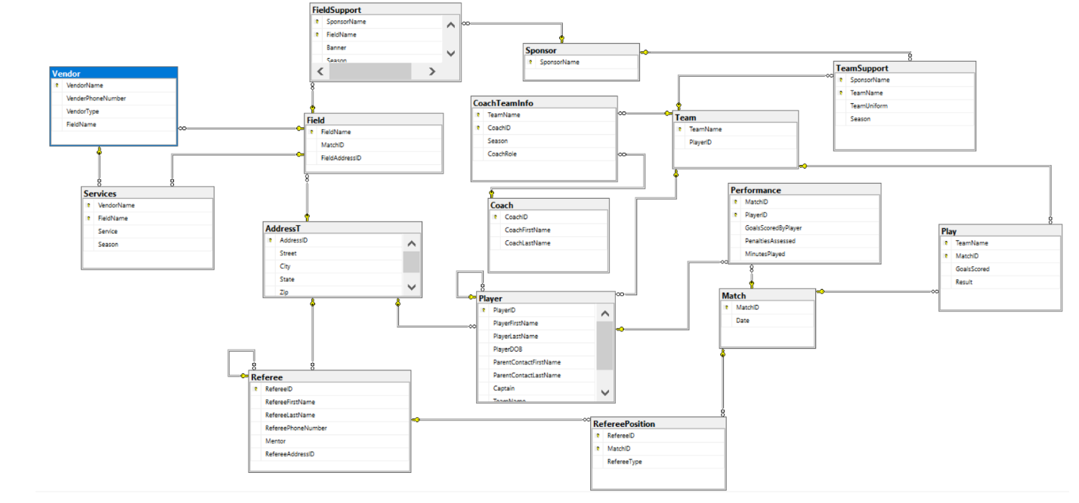The layout and relationships of this database

(for the curious)